TryHackMe Room Report: Windows Fundamentals 2
Week: 2
Topic: Windows Administration and Security
Platform: TryHackMe
Date Completed: 26 October 2026
1. Objective
The objective of this exercise was to understand additional Windows administration features, learn about system configuration and security tools, and explore how Windows utilities support system monitoring and cybersecurity investigations.
2. Concepts Learned
- System Configuration (MSConfig)
- Computer Management
- System Information
- Resource Monitor
- Command Prompt
- Windows Registry
- Windows Update
- Windows Security
- Windows Defender Firewall
3. Tasks Performed
- Explored Windows system configuration and administrative utilities.
- Reviewed System Information to understand operating system and hardware details.
- Learned how Resource Monitor displays CPU, memory, disk, and network activity.
- Explored the Windows Registry and its role in storing system and application settings.
- Reviewed Windows Update and the importance of installing security patches.
- Studied Windows Security features and Windows Defender Firewall.
- Learned how built-in Windows tools help administrators monitor and secure systems.
4. Commands and Tools Used
Tool 1: System Information
Command: msinfo32
Explanation: Opens System Information, which displays details about the computer's hardware, system components, and software environment.
Tool 2: Resource Monitor
Command: resmon
Explanation: Opens Resource Monitor to inspect CPU, memory, disk, and network resource usage.
Tool 3: Registry Editor
Command: regedit
Explanation: Opens Registry Editor, which allows authorized users to view and manage Windows registry settings.
Tool 4: Windows Update
Tool: Settings → Windows Update
Explanation: Used to review Windows updates and understand how patches help fix security vulnerabilities and system issues.
Tool 5: Windows Defender Firewall
Command: wf.msc
Explanation: Opens Windows Defender Firewall with Advanced Security to review firewall rules and network traffic controls.
5. Findings and Observations
- System Information helps administrators understand the computer's configuration.
- Resource Monitor helps identify processes consuming system resources and inspect network activity.
- The Windows Registry stores configuration settings used by the operating system and applications.
- Regular security updates help protect systems against known vulnerabilities.
- Windows Security provides built-in protection and security management features.
- Firewall rules help control incoming and outgoing network traffic.
- SOC Analysts can use knowledge of Windows tools and system behavior to investigate suspicious processes, configuration changes, and possible security incidents.
6. Screenshot
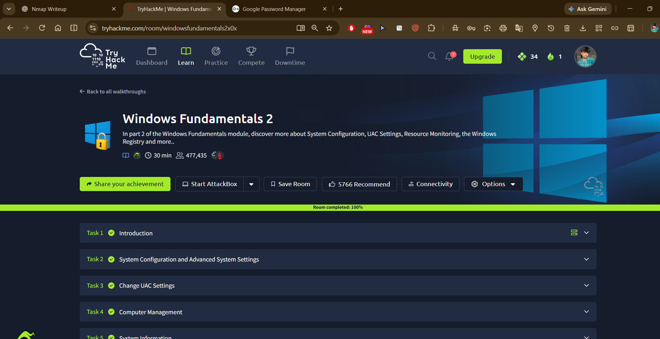Caption: Successfully completed Windows Fundamentals 2 and reviewed Windows system administration, configuration, and security tools.
7. Challenges Faced
The main learning challenge was understanding the purpose of different Windows utilities and how system configuration, registry settings, resource monitoring, and security updates contribute to system protection.
8. Conclusion
This exercise improved my understanding of Windows administration and security features, including system monitoring, registry configuration, updates, and firewall management. These skills are useful for endpoint monitoring, Windows security investigations, and SOC Analyst activities.

